**USER MANUAL FOR EMPLOYEE PAYROLL MANAGEMENT SYSTEM (EPMS)**

Purpose of software

This Employee Payroll management system is used to calculate salary of employees when user enters working and over time hours to the system.

Roles and responsibilities

|  |  |  |  |
| --- | --- | --- | --- |
| **S.no** | **User** | **Description** | **Use** |
| **1** | Administrator | Administrator got full access to the system | * Add/edit/delete employees * Add/edit/send for approval – Payments * Pay employees/Amend payment details for further revision * Manage User accounts * Edit Payrates for staff types * Own User profile edit access |
| **2** | Accountant | Accountant got limited access to functions. | * Add/edit/send for approval – Payments * Own User profile edit access |

**Login Process flow EPMS**

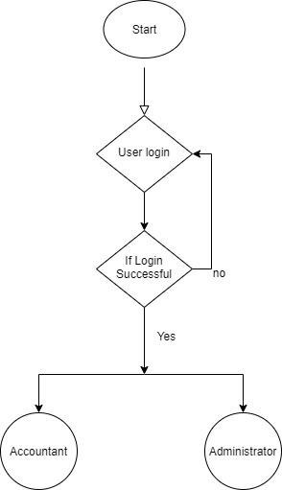

**What is the purpose of this application?**

Main goal of this module is to Develop an Employee Payroll Management System including a database with all the necessary information.

The main activities and functions of these module are:

* Manage Employee details
* Manage Payroll function
* Manage system user accounts
* Manage Payrates for each staff

**Guide**

**Step 1 - Opens the website through provided link - (https://epmscsu.com ), the login page appears as shown in figure 1.**

Note - There are two account types – Administrator and Accountant

This user guide will describe steps for administrator accounts because administrator account includes all functions available for ‘accountant’ users

Note - Clicking on home button will always redirect back to main functions.

**Step 2- After login is success, you will be able to see page like following**

There are three main functions you can access as an administrator and for accountant will get only one (Payments).

Step 3,4,5 expands main three functions.

Step 6,7 derives the way to access settings and my profile.

**Step 3- Access Payments Function, for Payments -Admin Panel move to Step 4, For Employee function move to Step 5.**

Step3A – When you access payments, you will get a screen as follow,

Step 3B –When you select employee Id, all recorded employee info will be filled in relevant fields automatically (highlighted above)

Step3C – Fill all relevant information in text areas. If you put incorrect values system will automatically show you a message, and you have to insert info again.

Step3D- After filling correct value, Press Add Payment. It will pop up a message and will add payment record as follows,

Step3E-To update payment record. Use edit button next to each payment record and follow the same steps used to add payment.

Step3F-To send payment details to administrator approval, please press send for approval button after ticking required checkboxes.

Note- Message will be shown to confirm that payment is successfully send to administrator and Selected payment records will be removed from the above list

**Step 4 – Access Payments-Admin Panel, for Employee function move to Step 5 (unavailable for accountants)**

Step 4A- you will get screen like this; Payments history records will be shown in the bottom list.

Step 4B- You can search payment record from given search box and to pay employee, you have to select checkbox and press pay button

Step 4C-To Amend payment from admin panel, you have to select record and press amend button.

Note- When user amend payment, record will be removed from admin panel and will add to payments area with a status message ‘Amend’, as follow,

**Step 5 – Access Employee function (unavailable for accountants)**

Step 5A- Screen will show as follows,

Step 5B- Fill all relevant information in text areas. If you put incorrect values or keep empty fields system will automatically show you a message, and you have to insert info again.

Step 5C - After filling correct value, Press Add Employee. It will pop up a message and will add employee record as follows,

Note - Search can be done using search box using same method used in payments-Admin Panel

Step 5D – To update employee record. Use edit button next to each employee record and follow the same steps used to add employee.

Step 5E – To delete employee record, you have to select required records and press Delete button.

Note- If there is an ongoing payment for the selected employee, you need to do payment before deleting.

**Step 6 – Access Settings (unavailable for accountants)**

**Step 6A – Accessing User Accounts- user can add, edit, delete user accounts.**

Step 6A1- User can enter information and add a new user to the system, as follows,

Note- Clicking show password will convert asterisk to letters.

Step 6A2 – Added user account will show as follows,

Step 6A3 – To update user account click edit button next to each record, will fill text areas with existing data.

Note- Password will not display for security measures, you can only update passwords.

Step 6A4 – To delete user select record and press delete button as did previously.

**Step 6B – Accessing Staff info and payrates will show as follows,**

**

**Step 6B2** – clicking updates rate button will update new values in the system and it will be used for future payments.

**Step 7 – Logout**

Simply click logout from anywhere

**END**